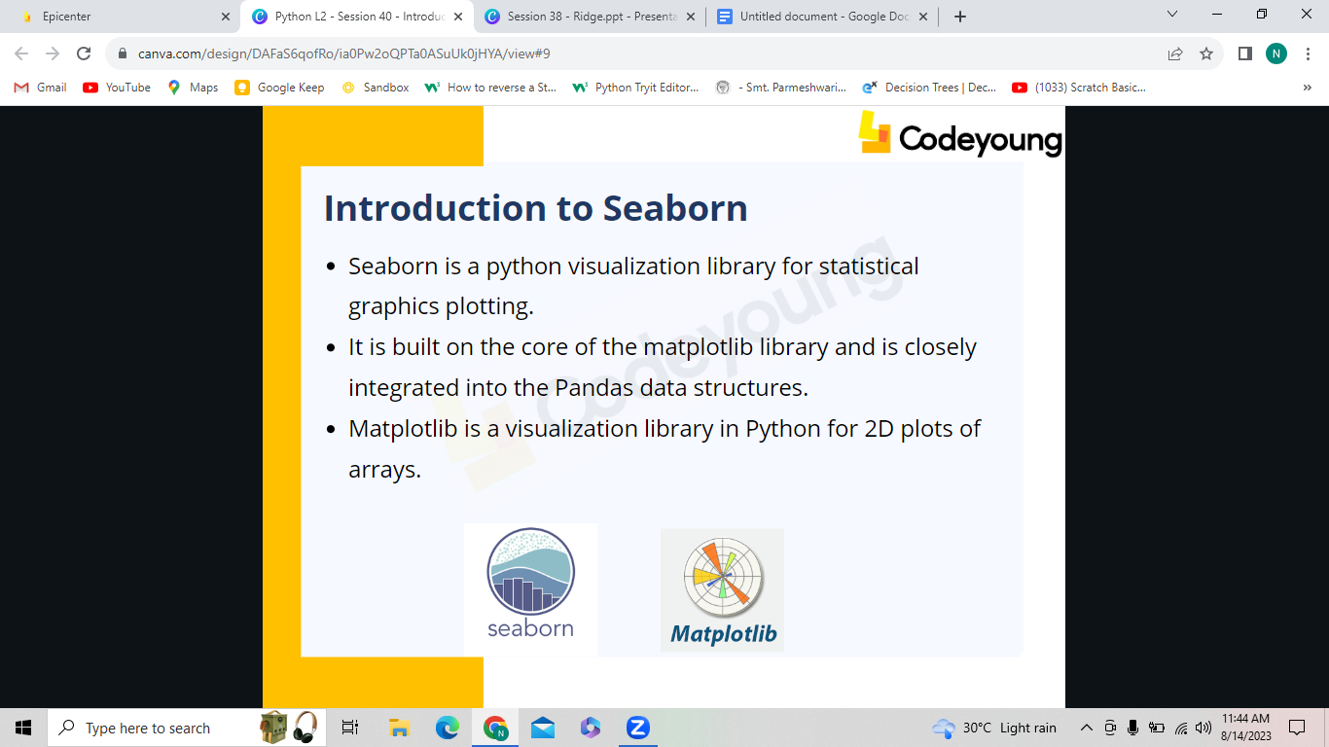

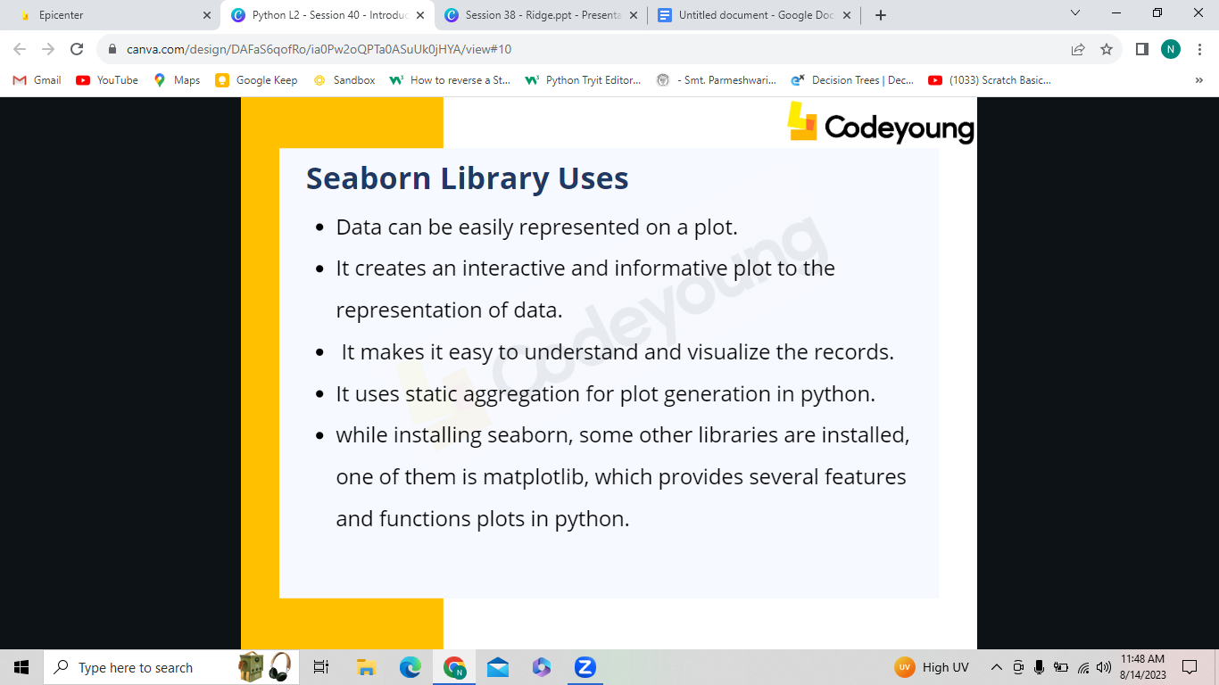

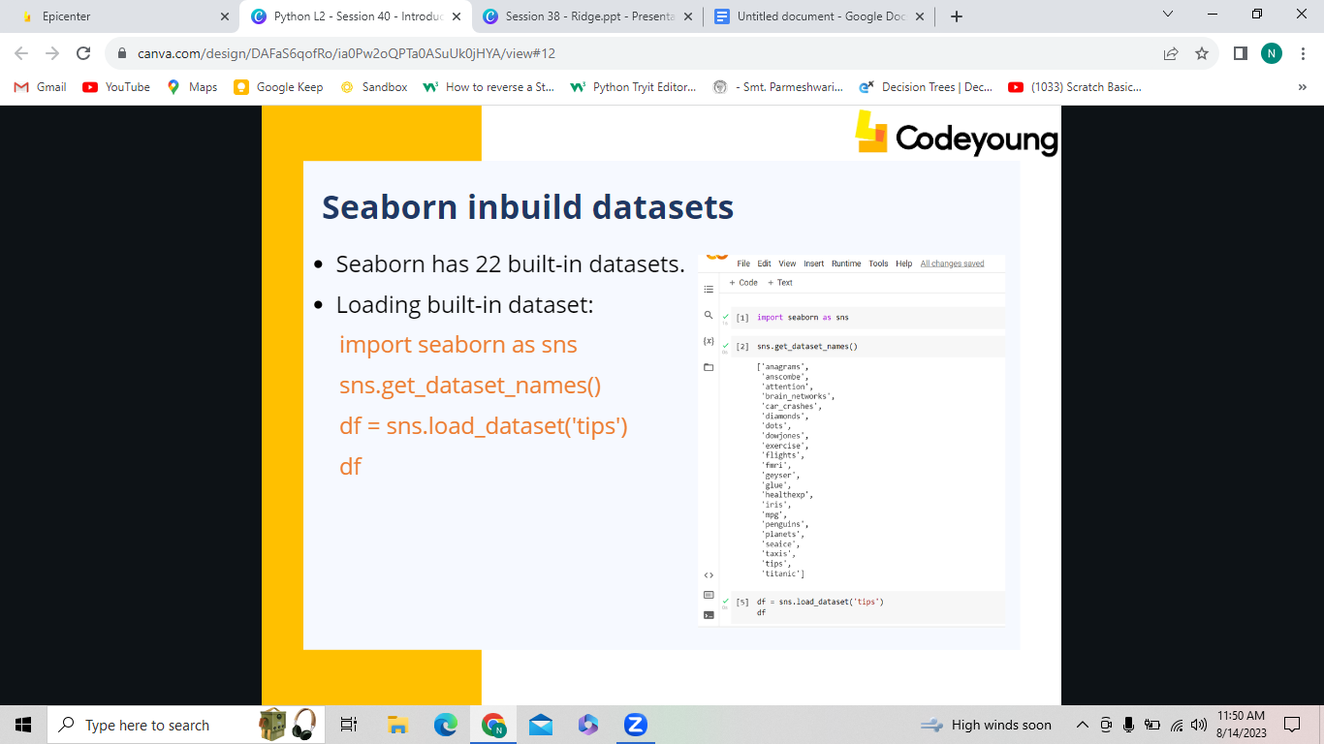

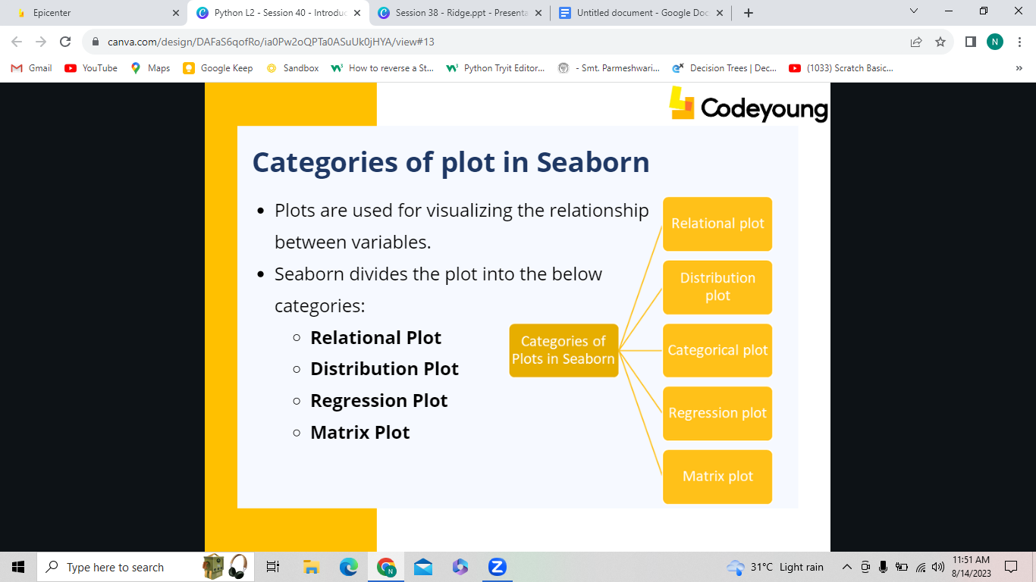

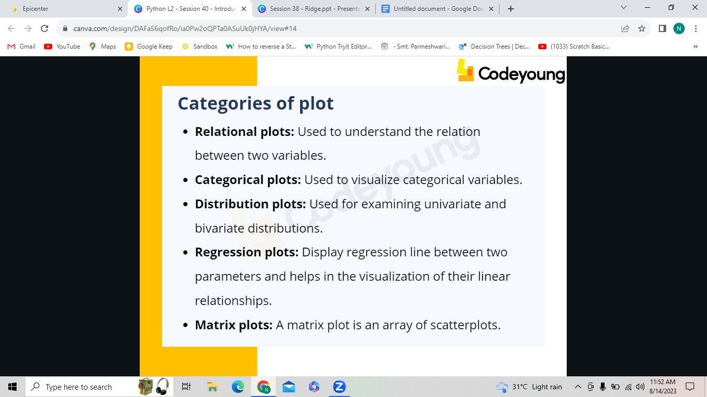

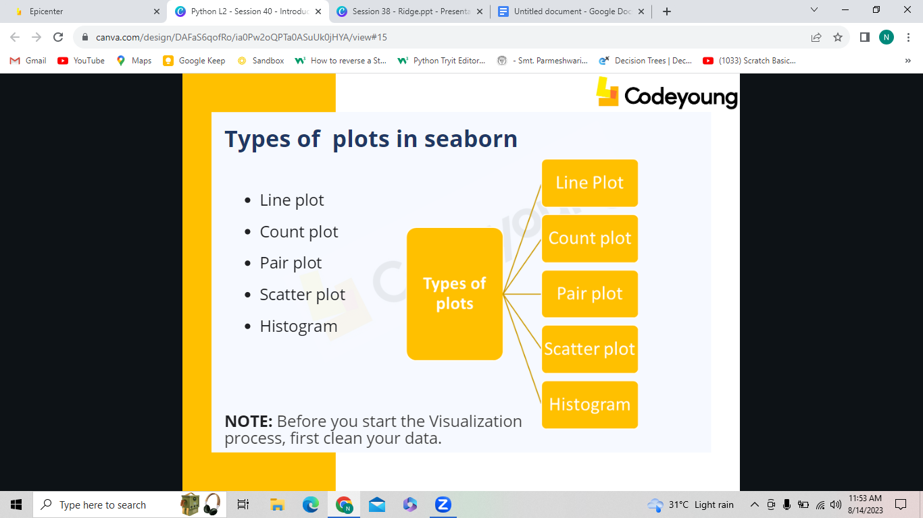

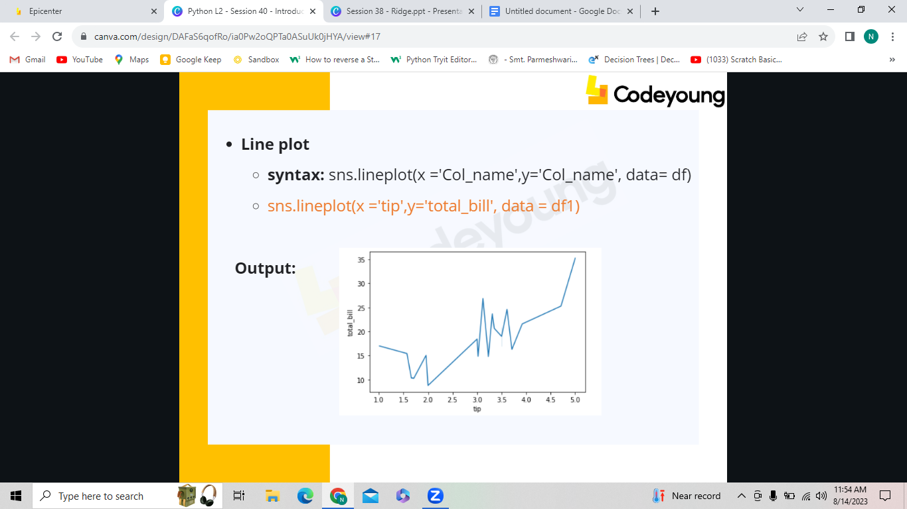

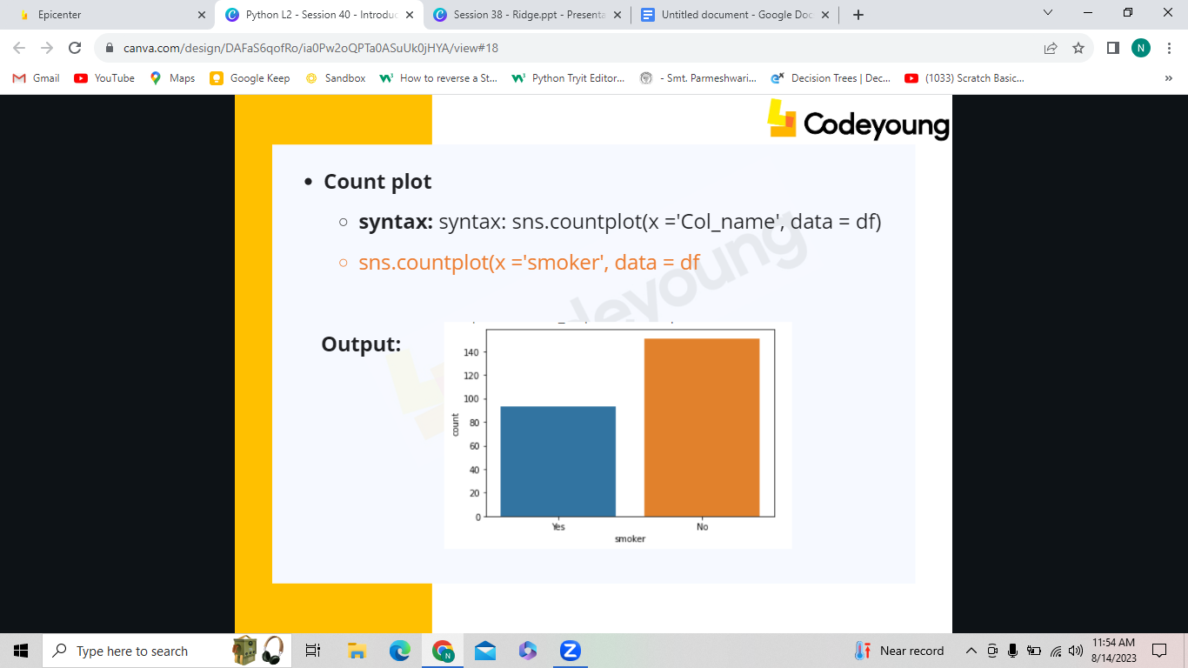

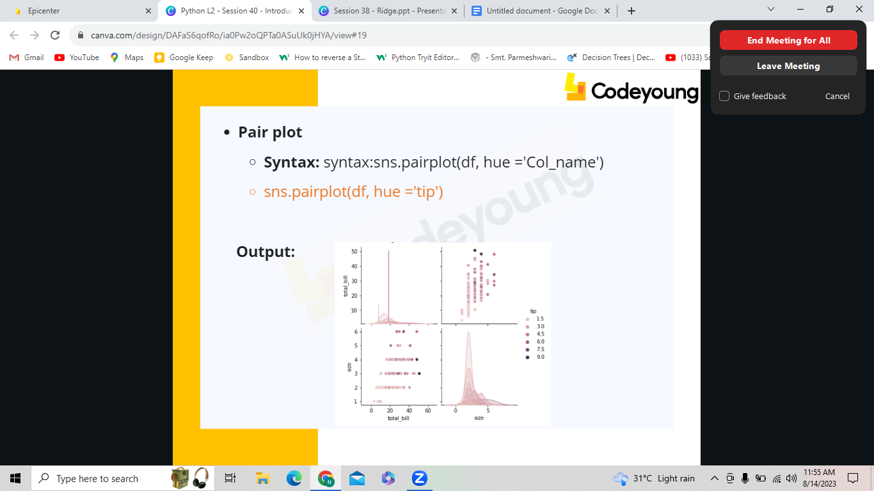

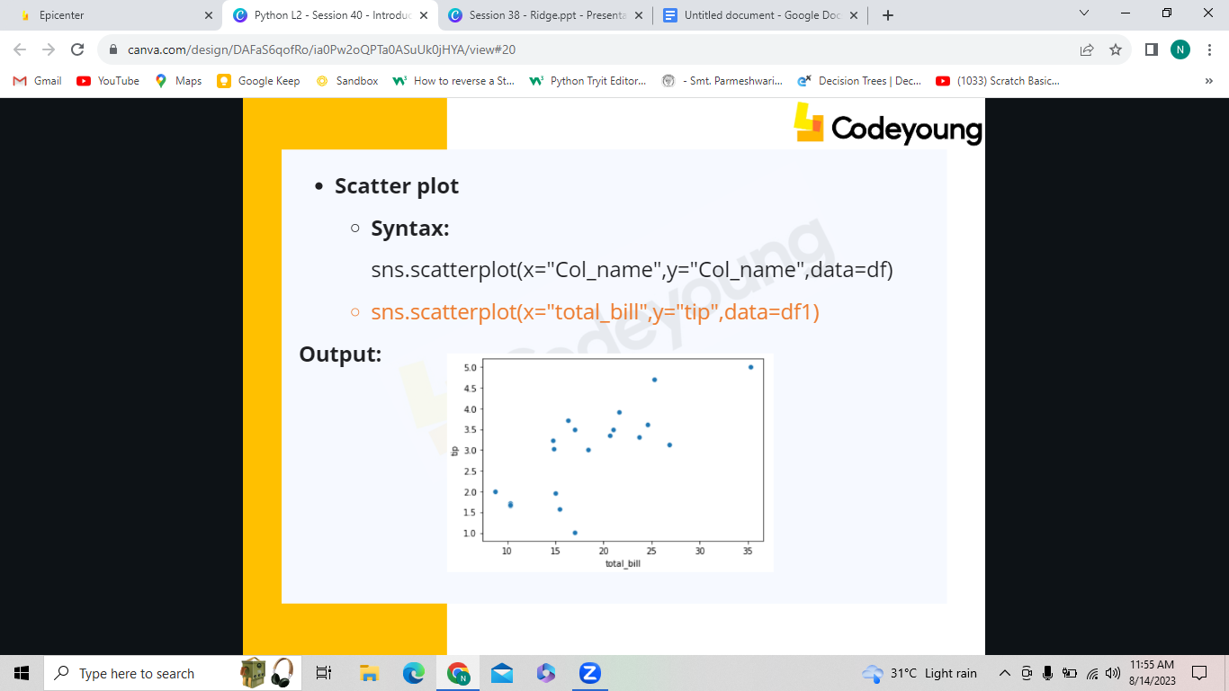

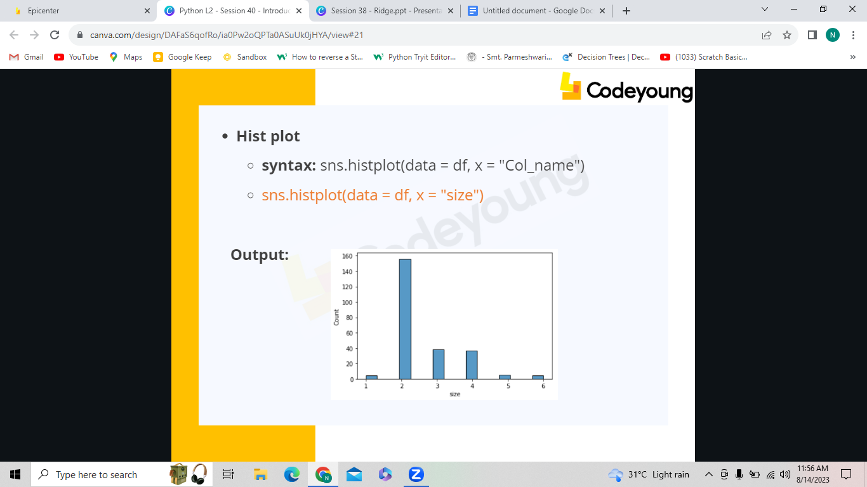

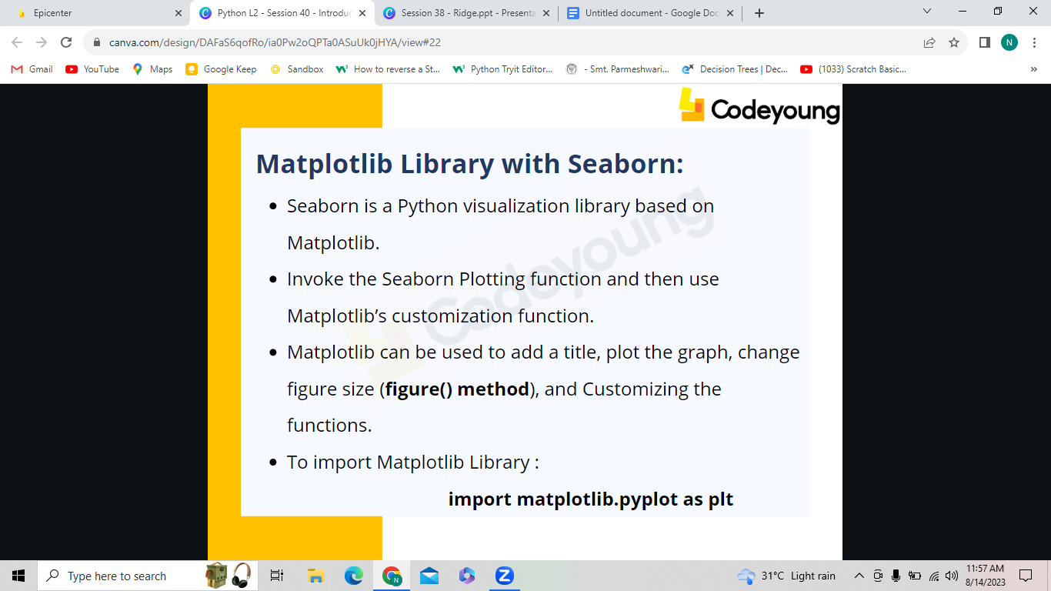

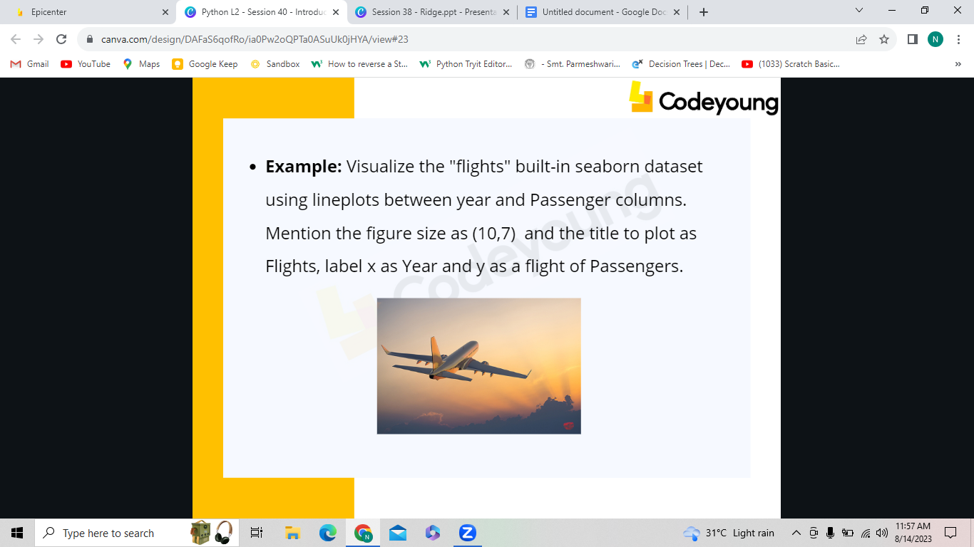

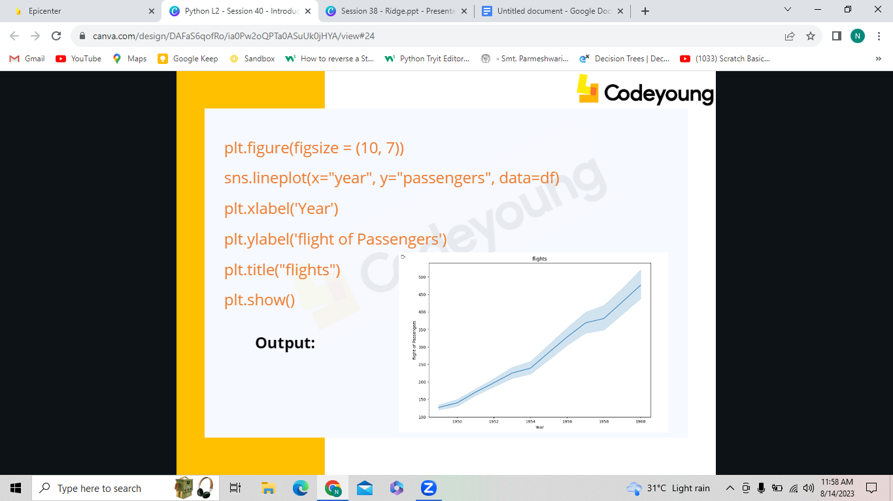

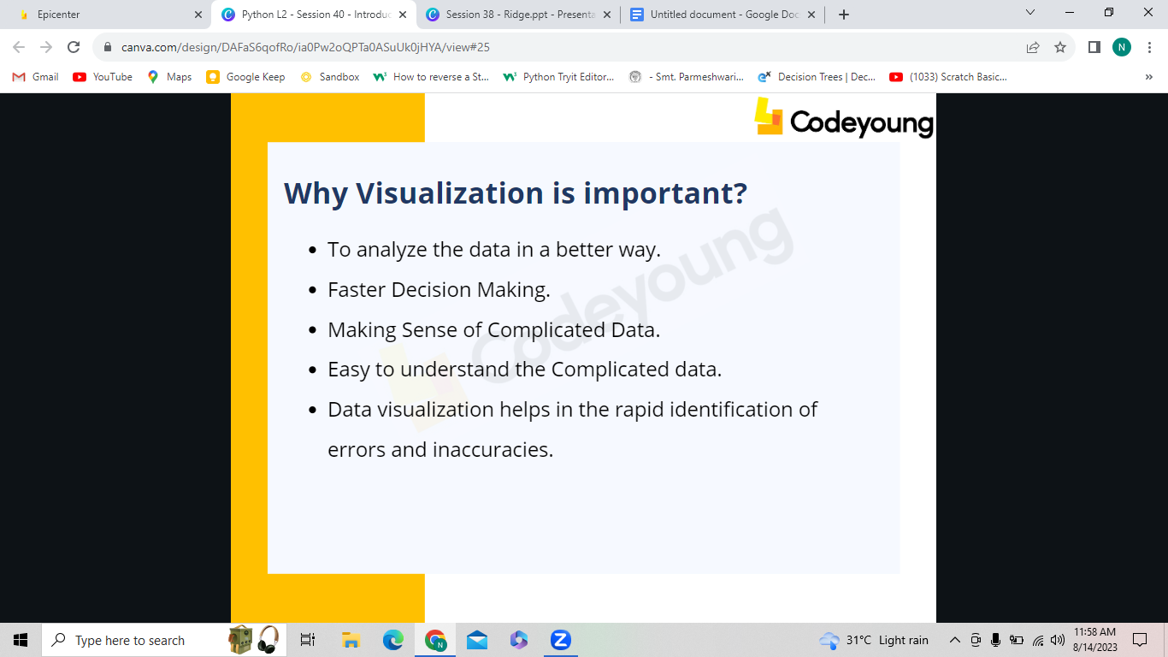

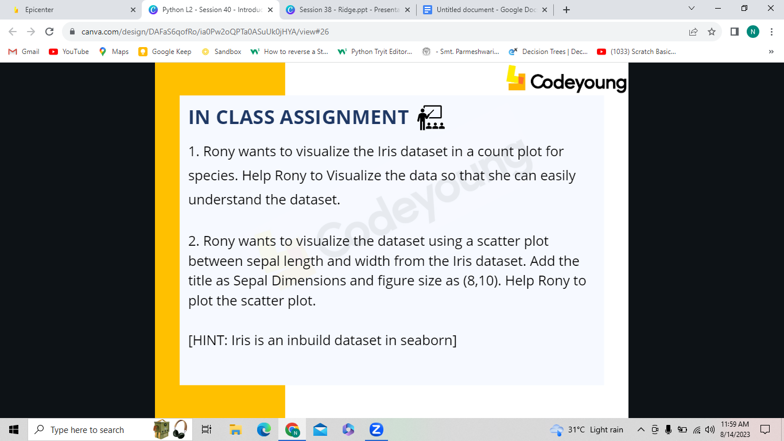

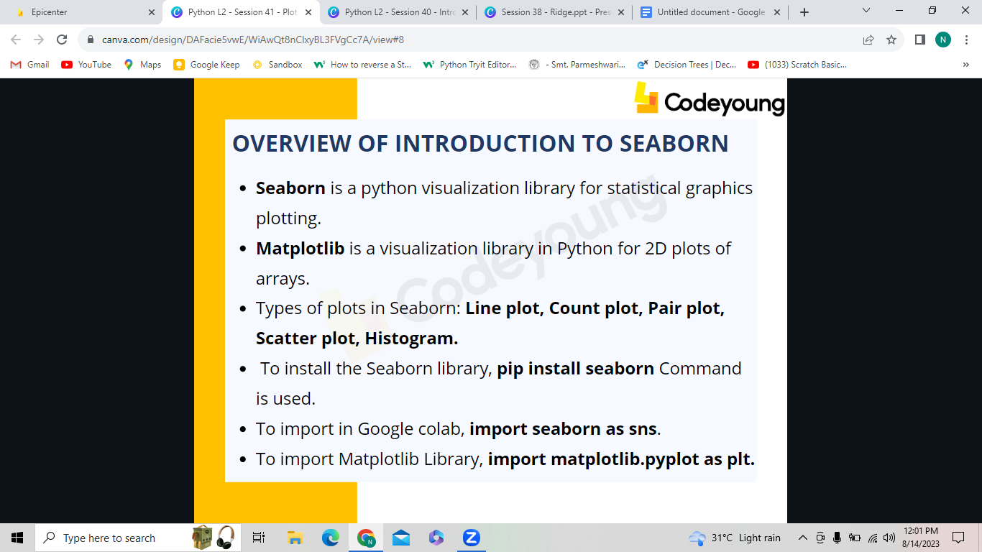

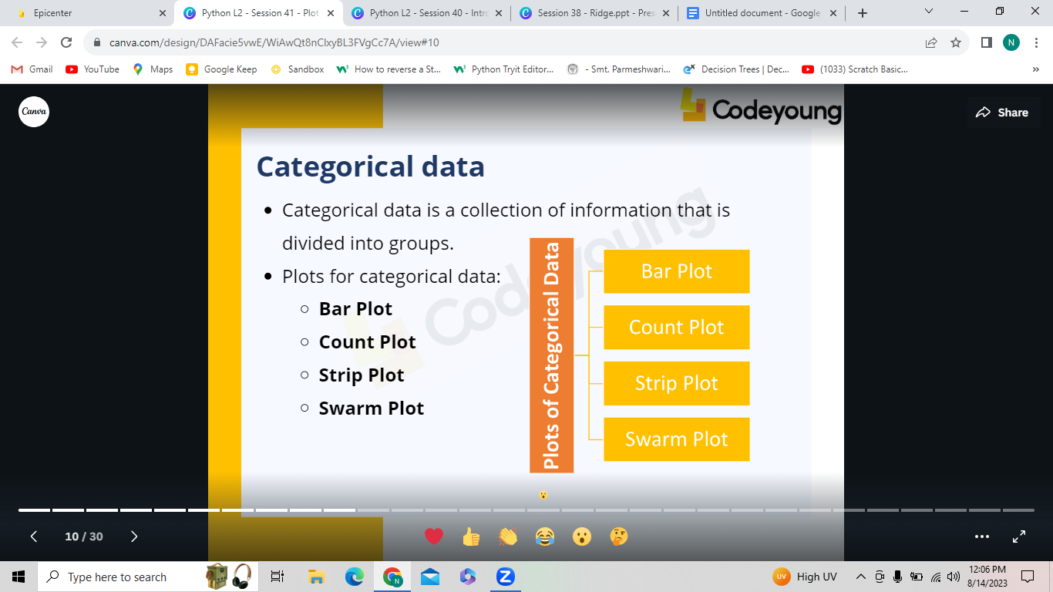

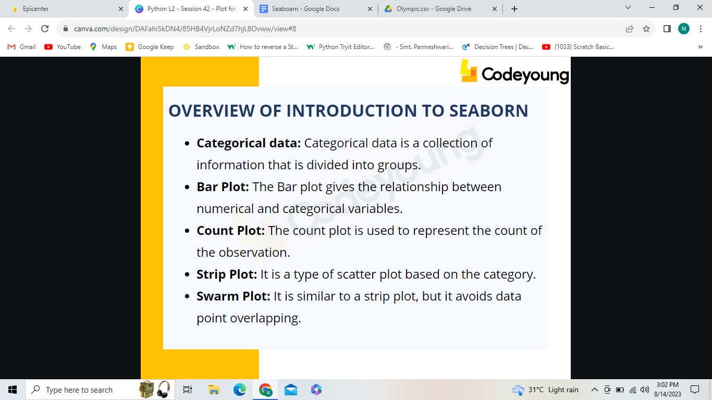

exercise dataset: :horizontal bar: sns.barplot(x="diet",y="id",data=df)

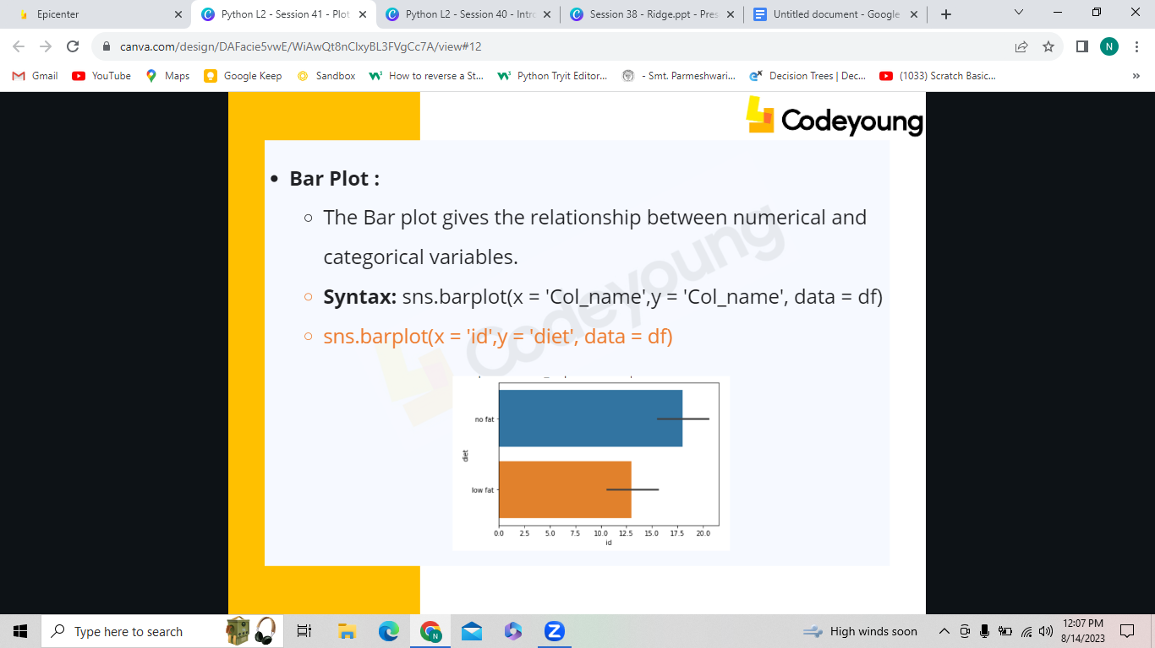

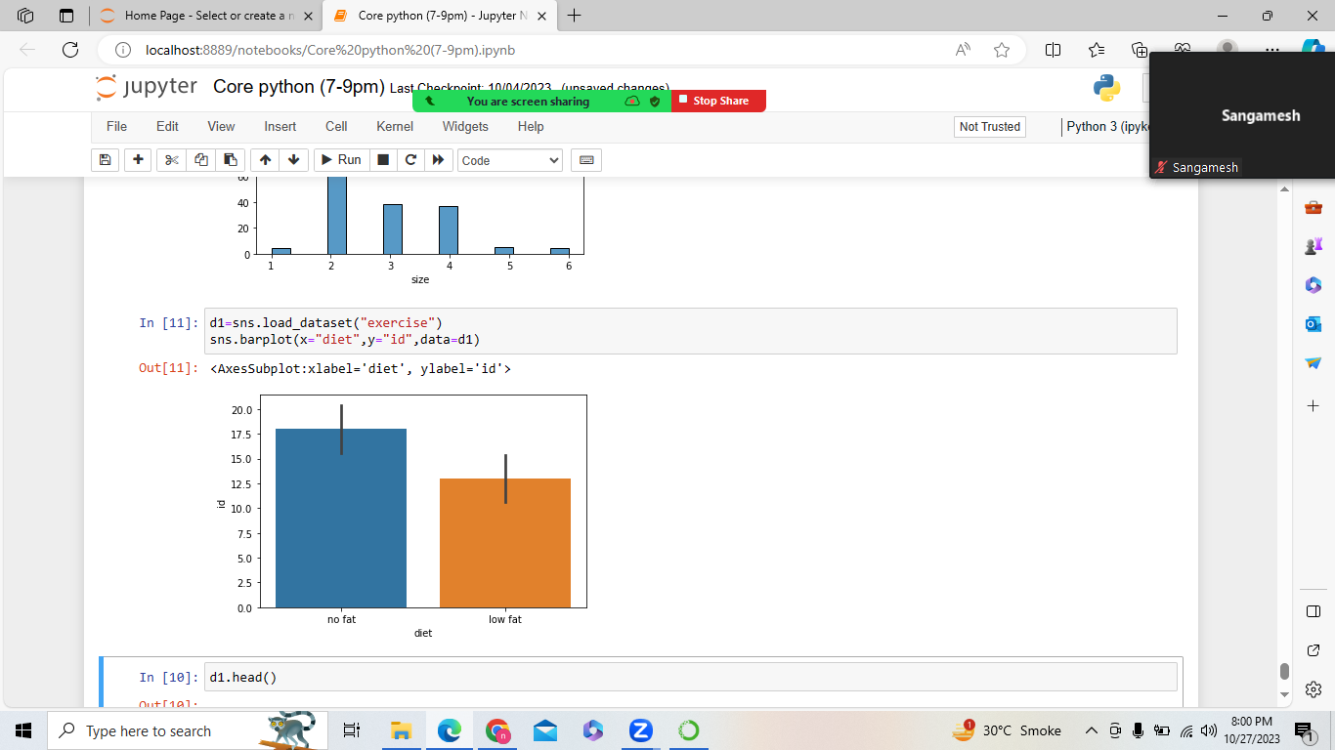

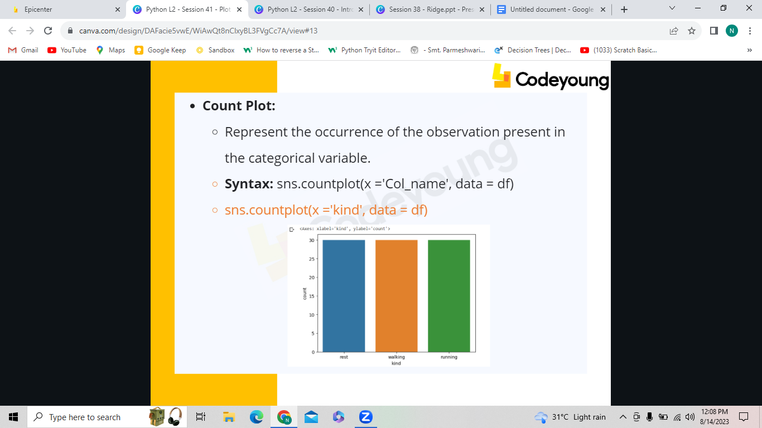

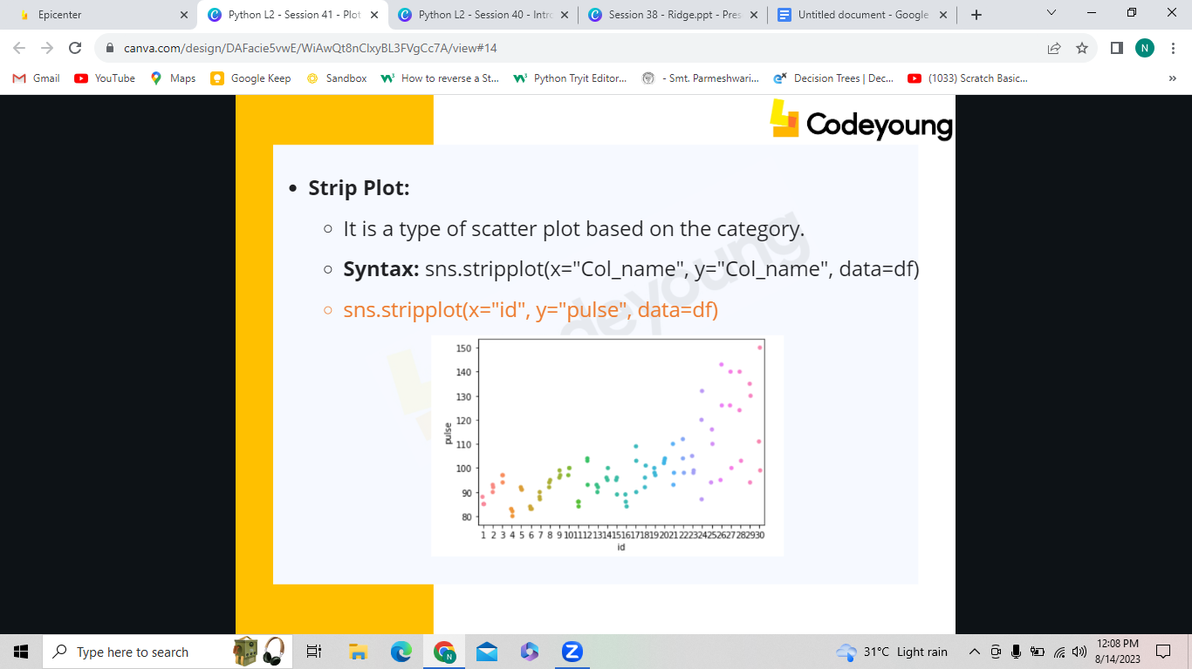

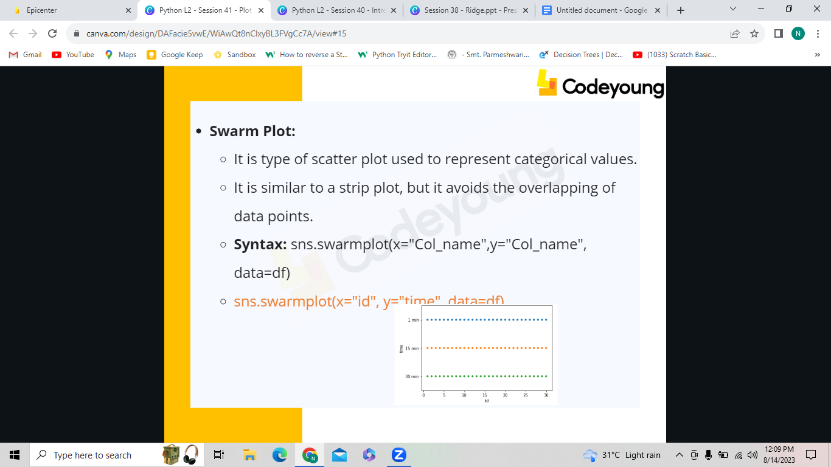

IRQ can Skip

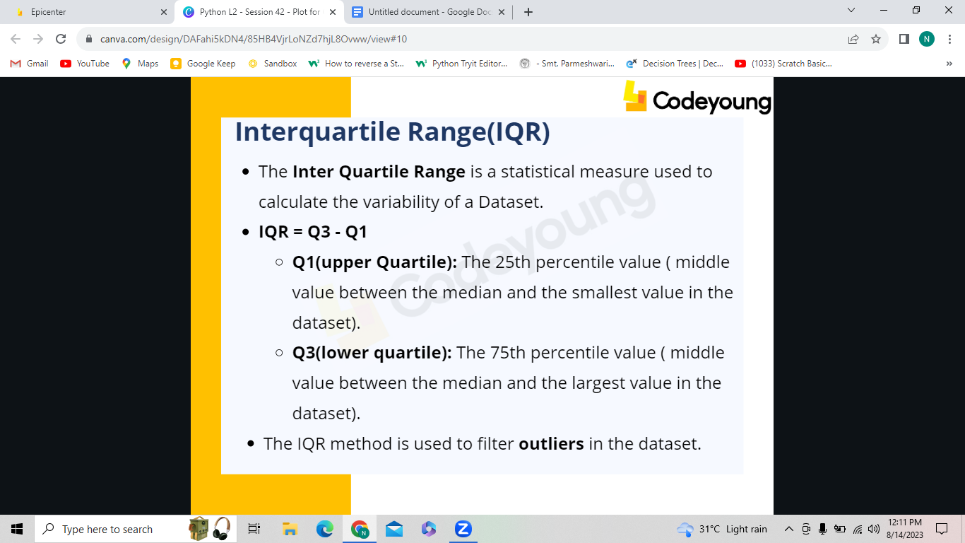

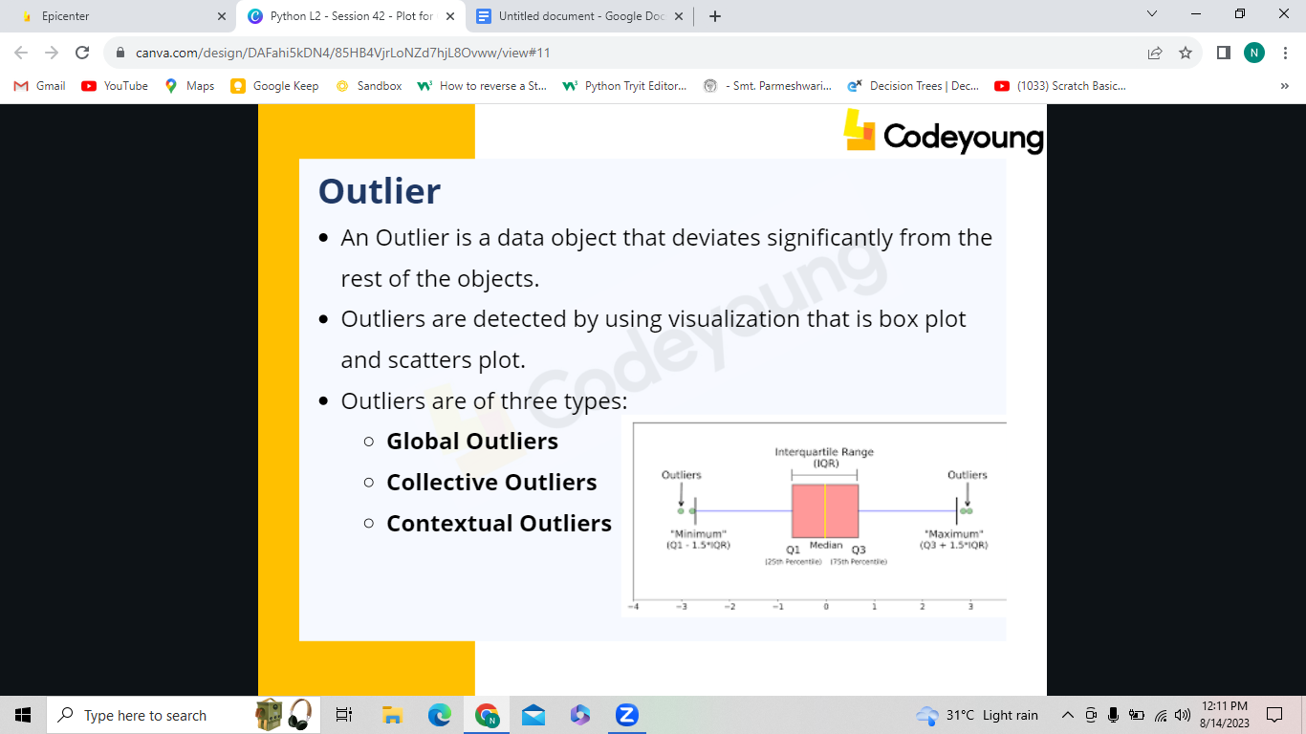

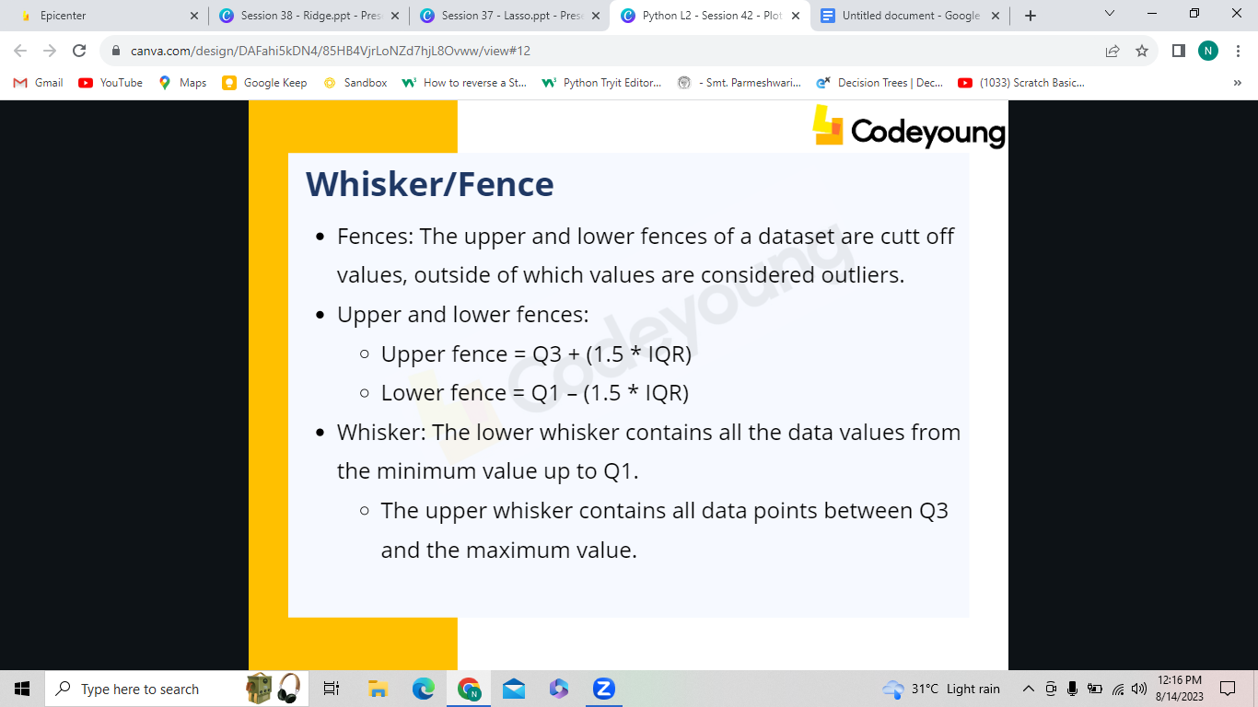

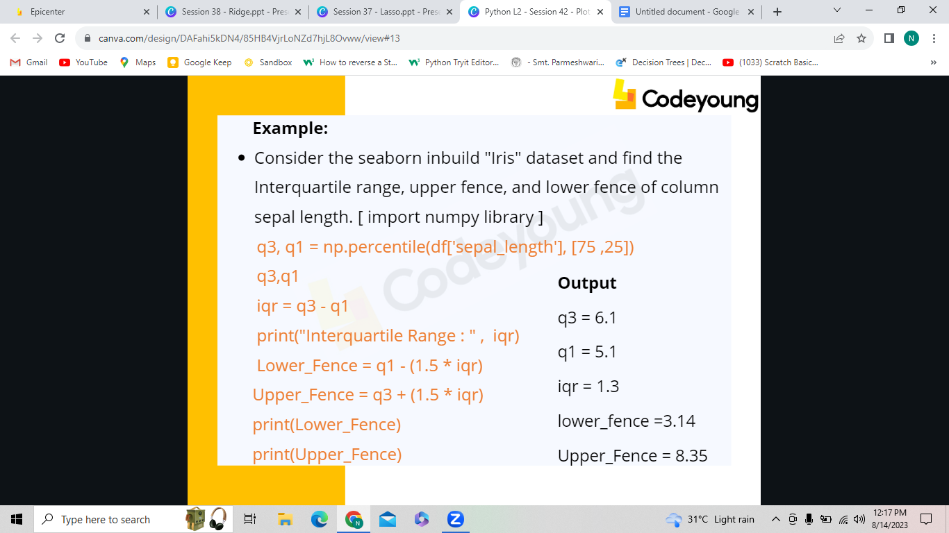

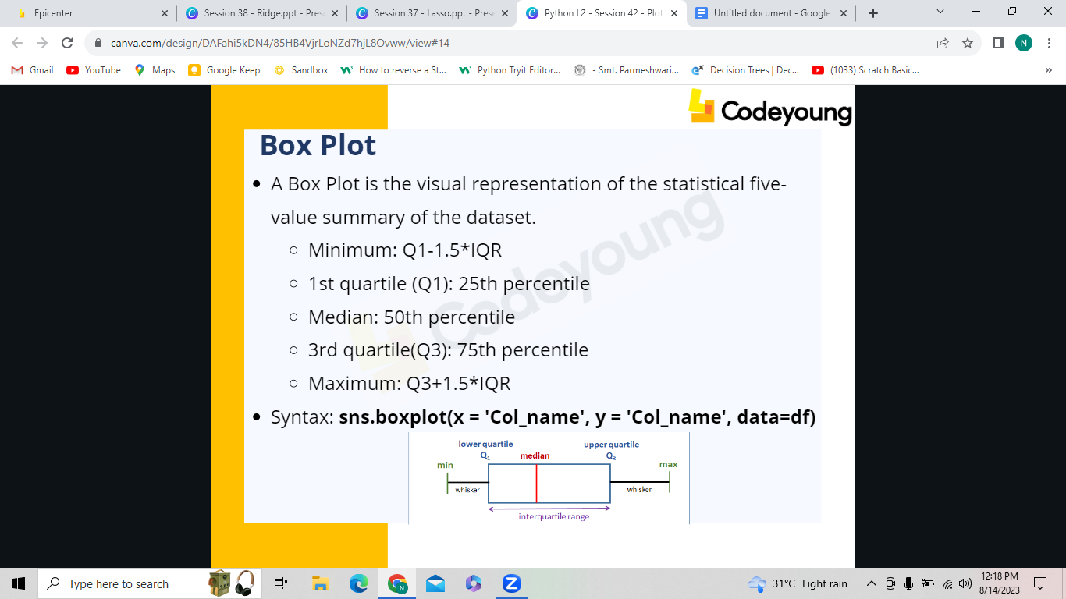

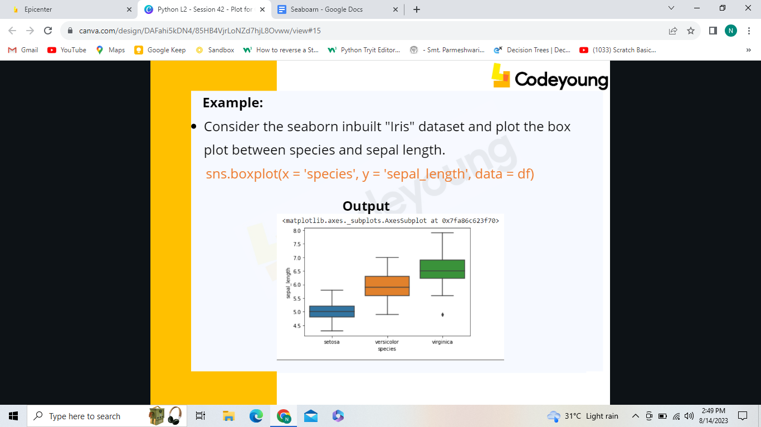

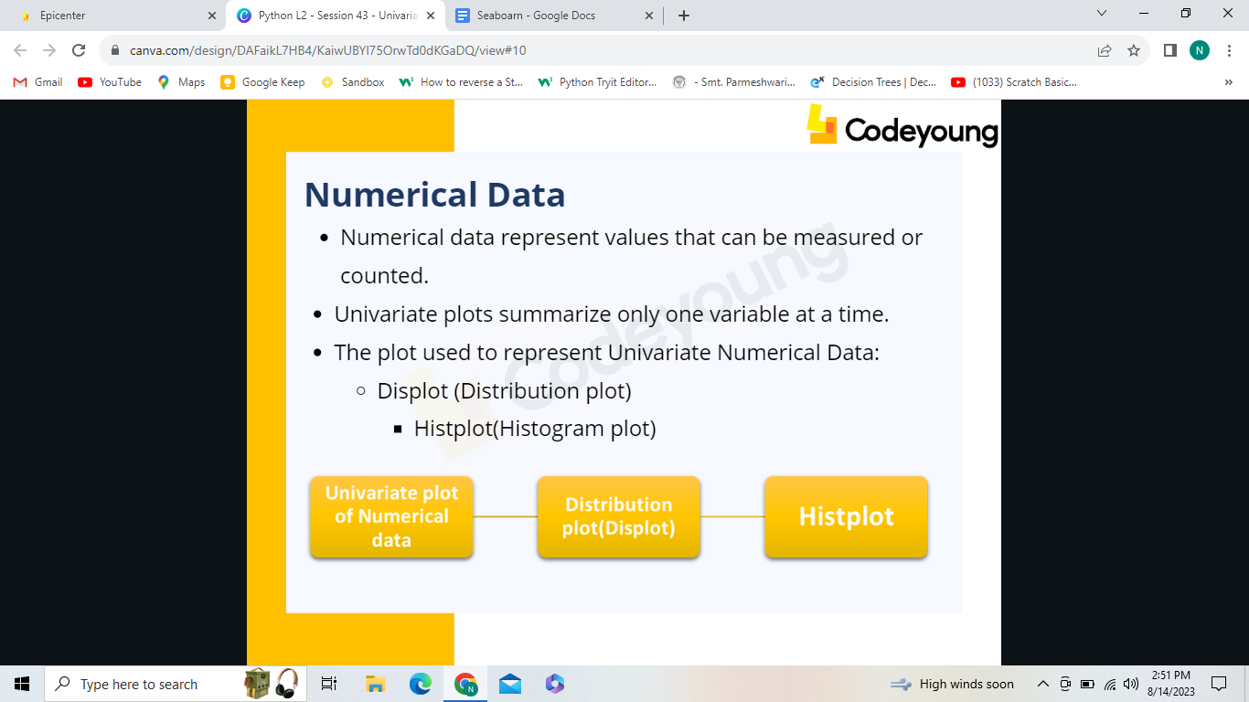

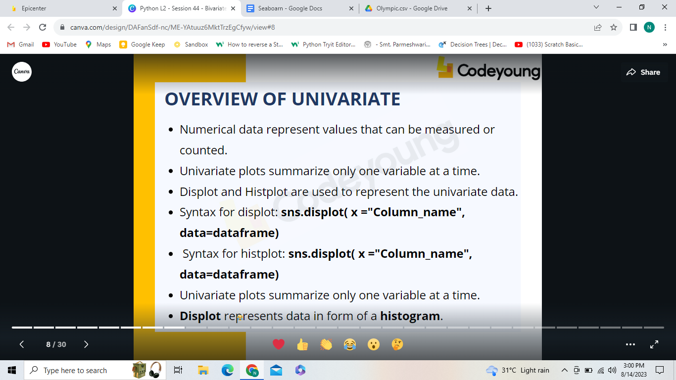

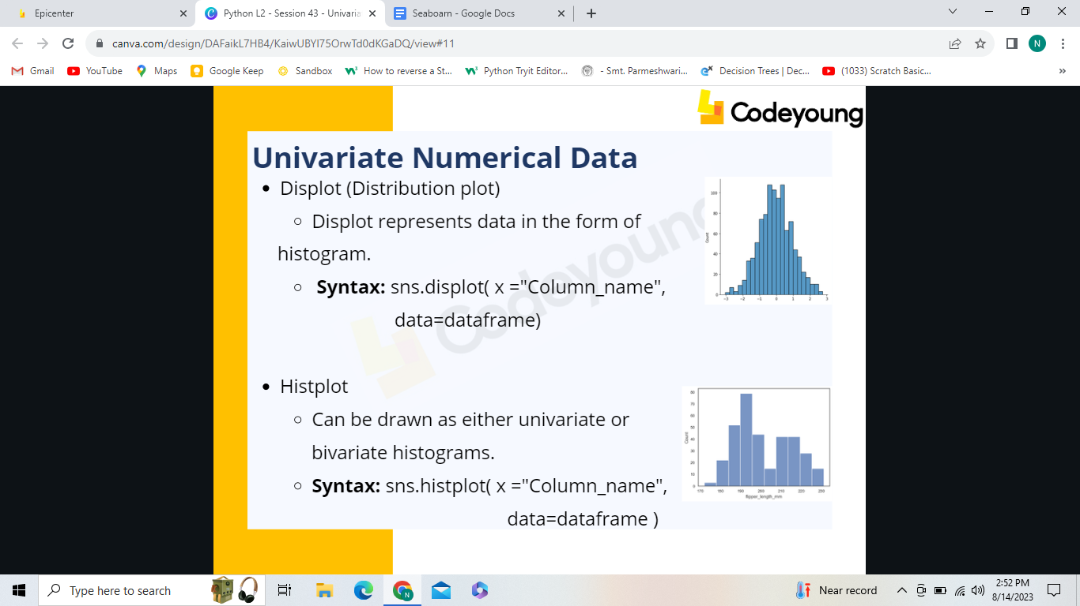

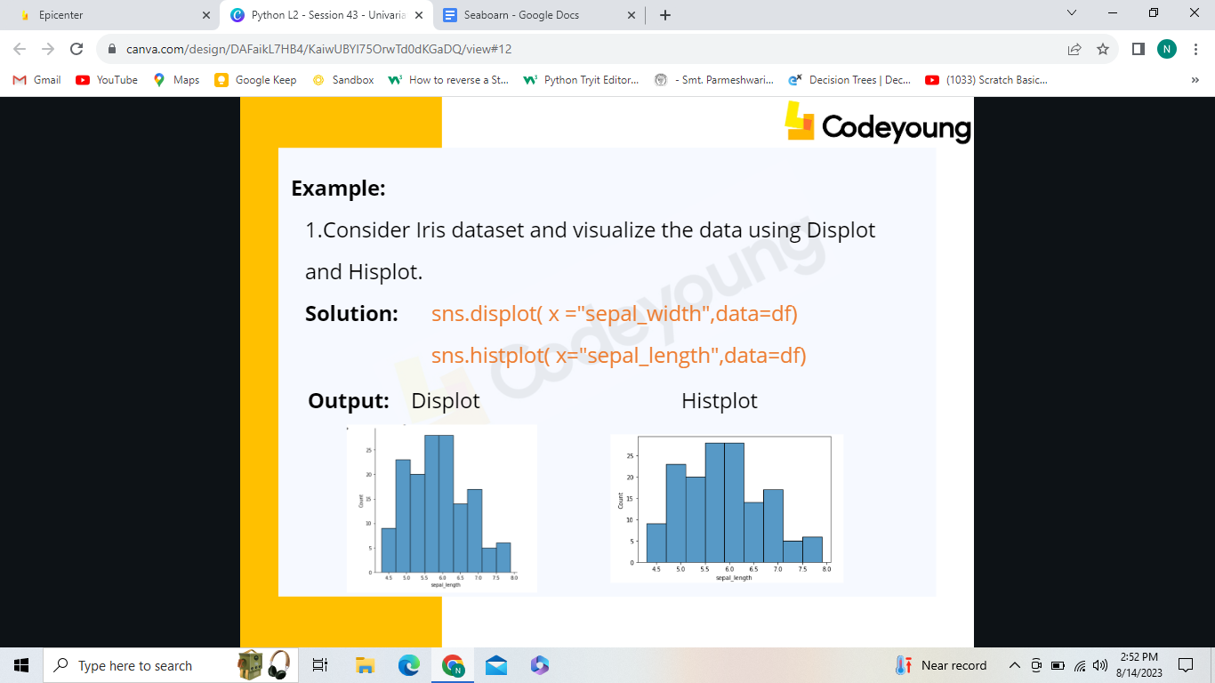

[Dataset link:

https://drive.google.com/file/d/1RZp8mXiSvQo_Kt6MG-

KxHLjo4m-4VTlb/view?usp=share_link]

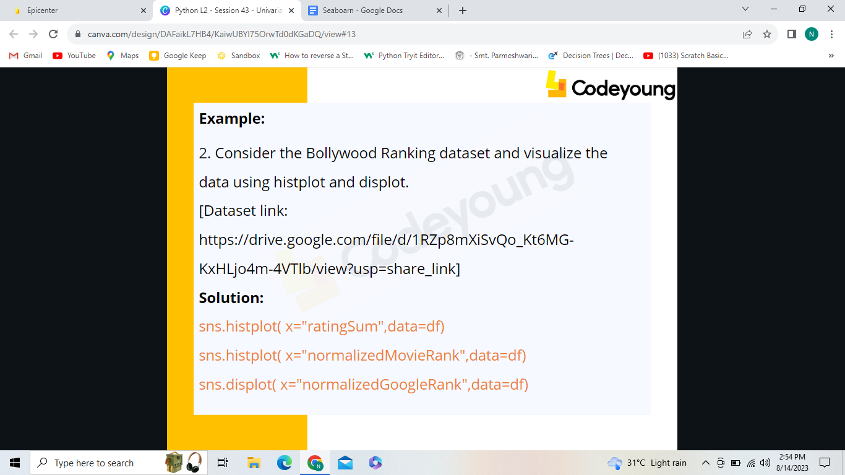

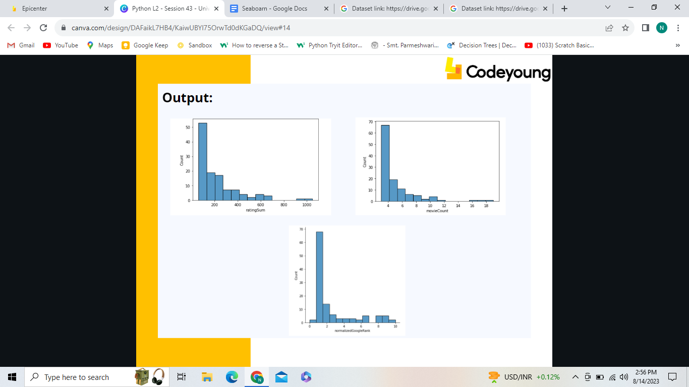

Inclass:1. Consider the Olympic dataset and visualize the data using displot for the medals column.

[Dataset link:https://drive.google.com/file/d/1qf4ptNSvohiBE3RrO23vEWDYvwHV-e6o/view?usp=share_link]

2. Consider the same dataset and visualize rows of index 11000 to 15000 using histplot for the city column.

**Bivariate:**

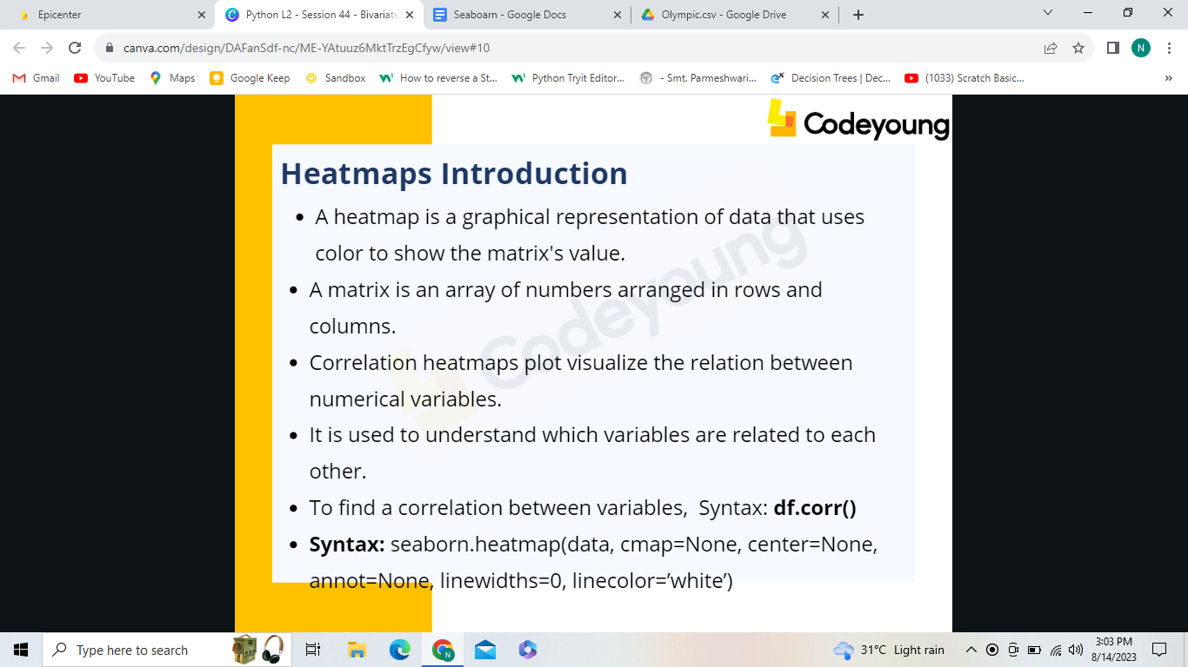

**Correlation heatmaps visualize the relation between numericalvariables.**

**Syntax:df.corr()**

**Syntax: seaborn.heatmap(data, cmap=None, center=None,annot=None, linewidths=0, linecolor=’white’)**

**Important parameters in the heatmap are data, cmap, centre,annot, linewidth, linecolor.**

**To display cell values, mention annot parameter as True.**

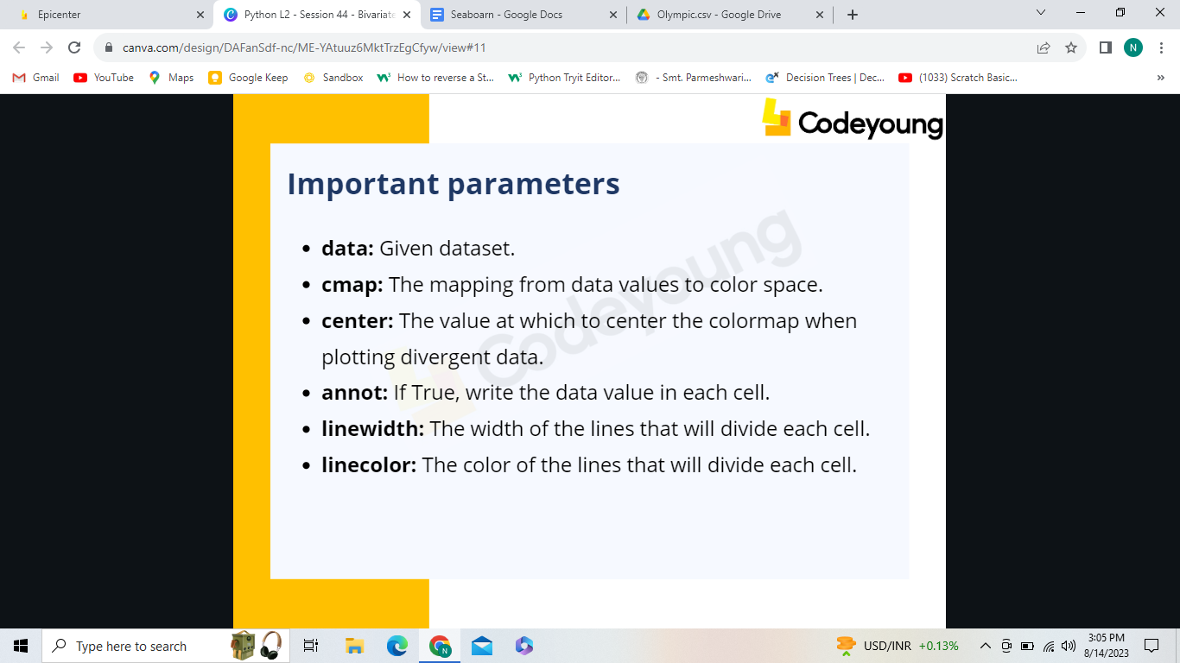

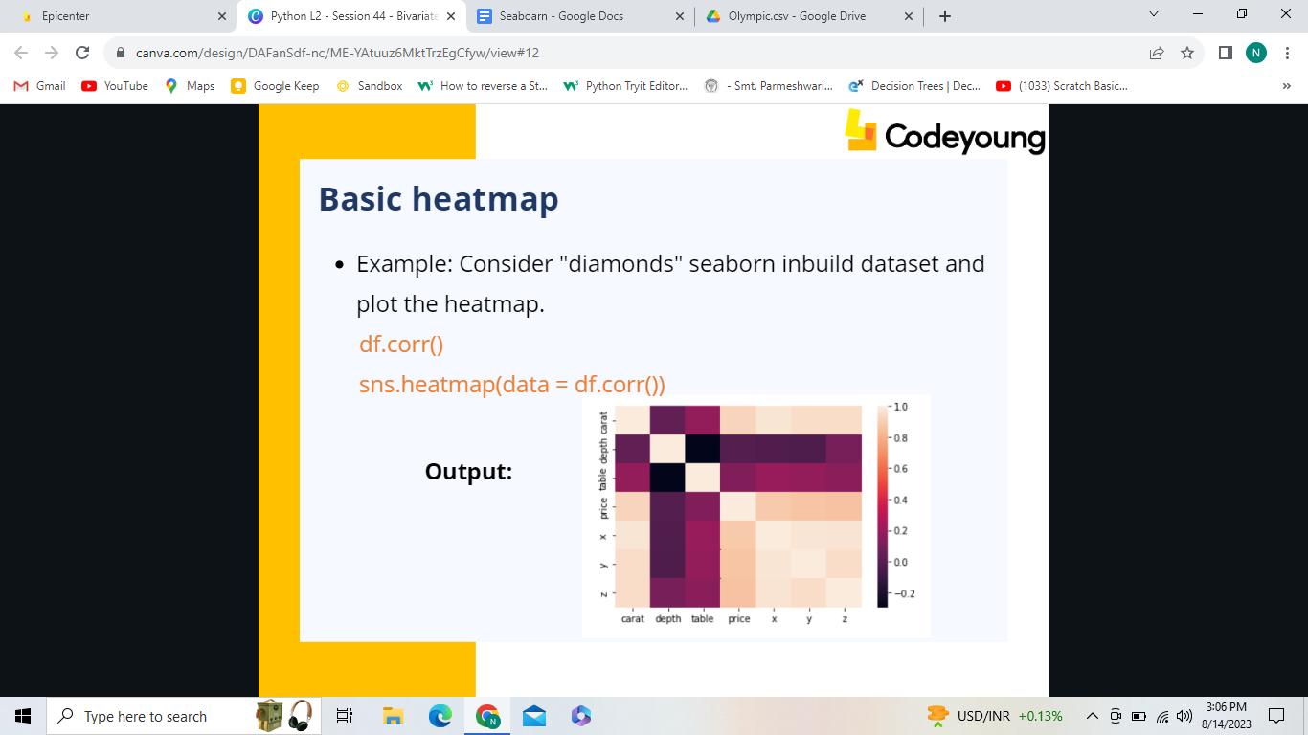

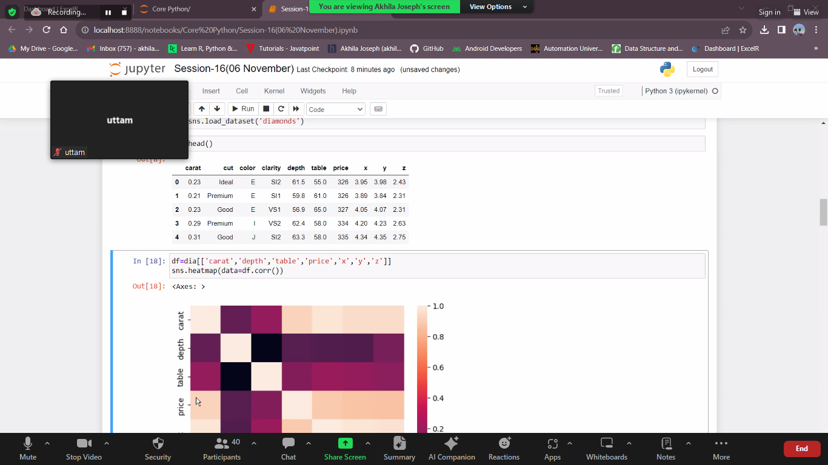

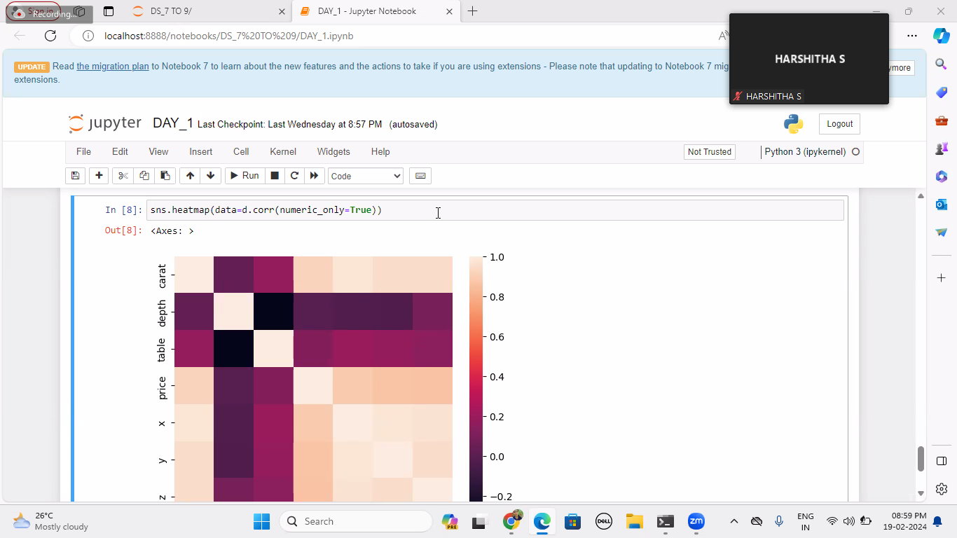

**Color link: https://matplotlib.org/3.1.0/tutorials/colors/colormaps.html**

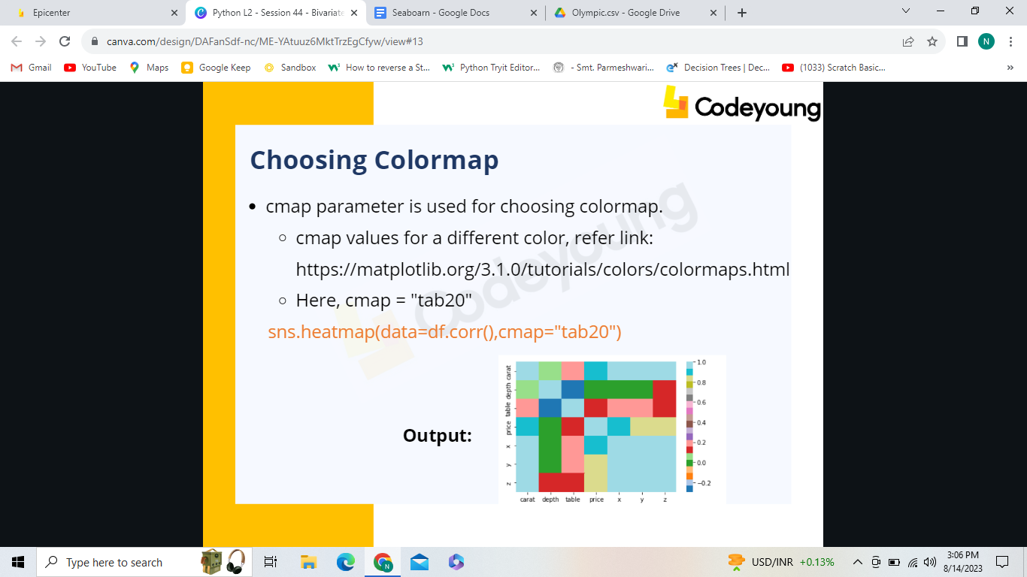

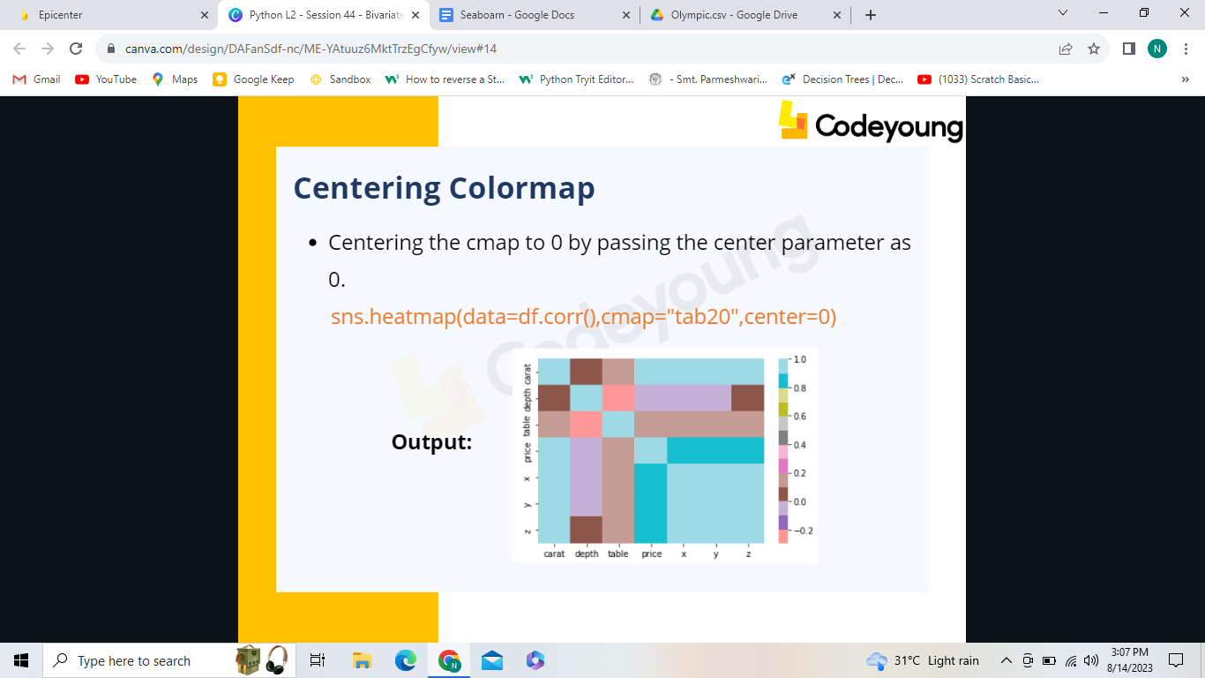

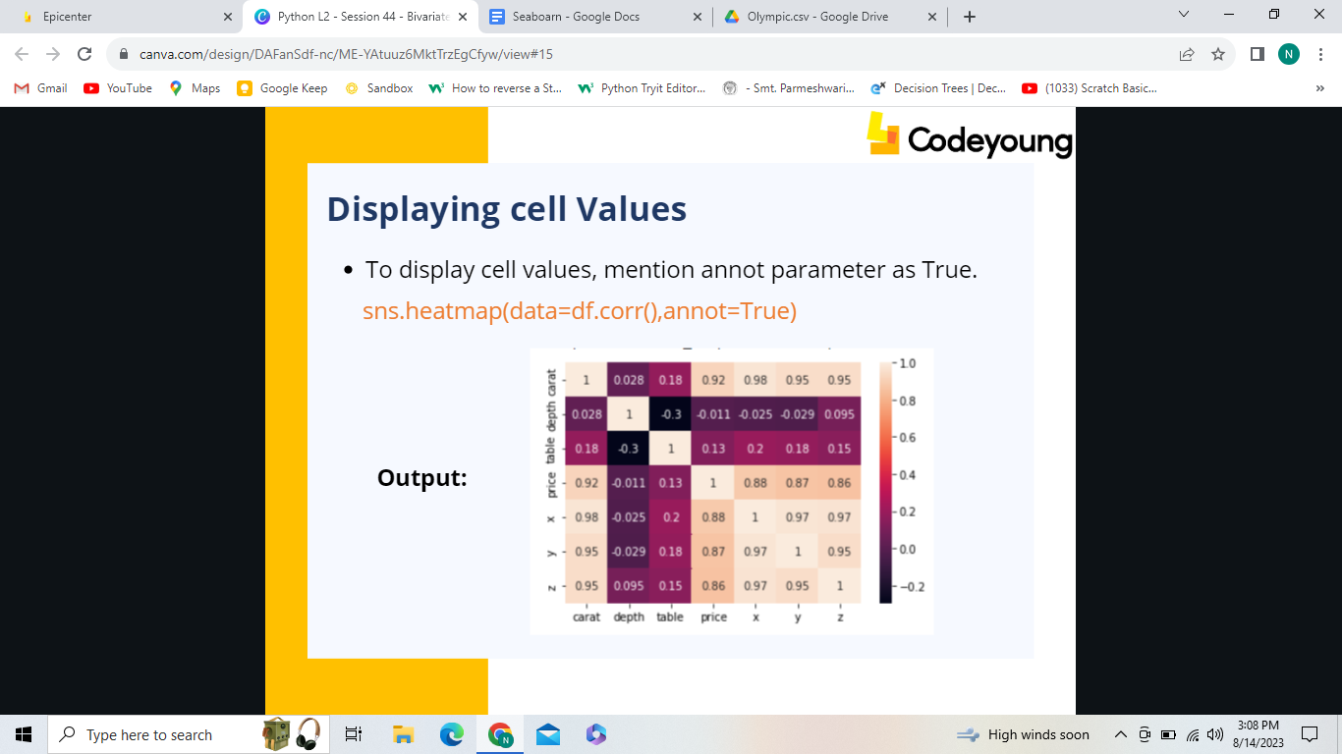

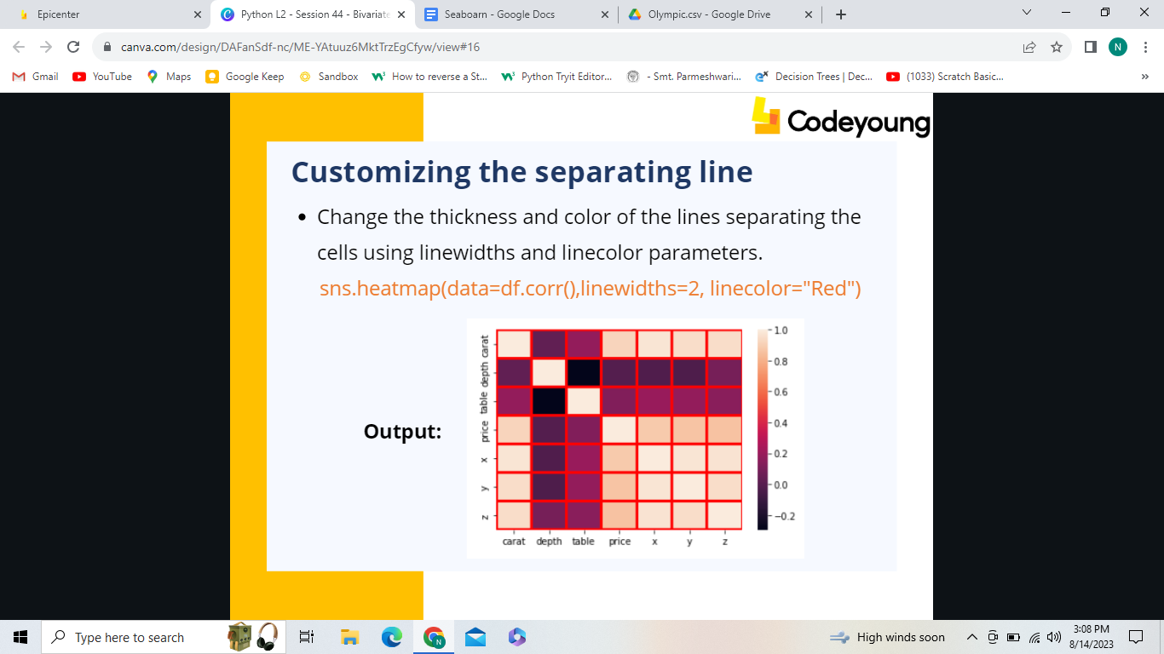

**IN CLASS ASSIGNMENT**

**1. Consider "attention" inbuild the dataset and visualize the data using heatmap with cmap value as tab20b.**

**2. Consider the "House Price Prediction" dataset and visualize the data by displaying the values in the heatmap.**

**[Dataset link: https://drive.google.com/file/d/1anrLBjpWmhZHHKuMDOjOdfILvr6UKZ7_/view?usp=share_link ]**

**Syntax: seaborn.jointplot(x, y, data=None, kind=’value’,hue='Col_name')**

**sns.jointplot(x = "mpg", y = "acceleration", data =df,hue='model_year')**

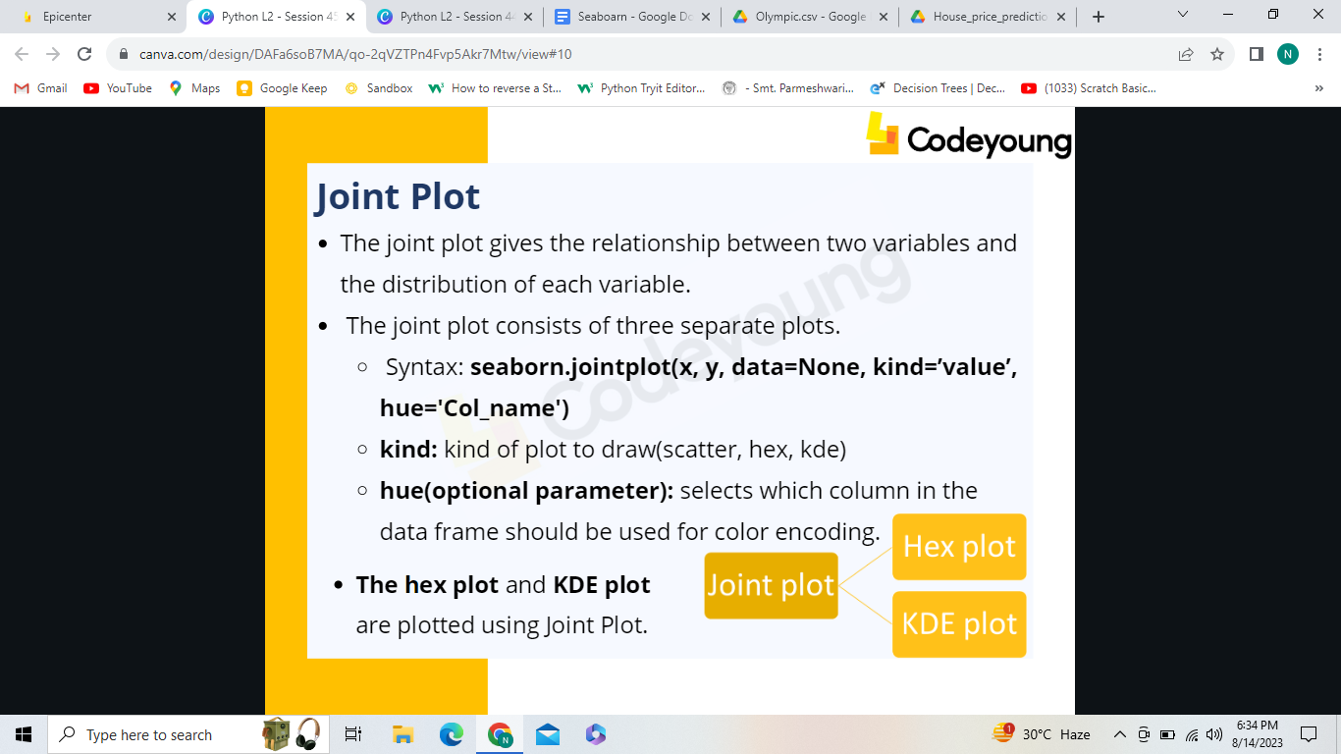

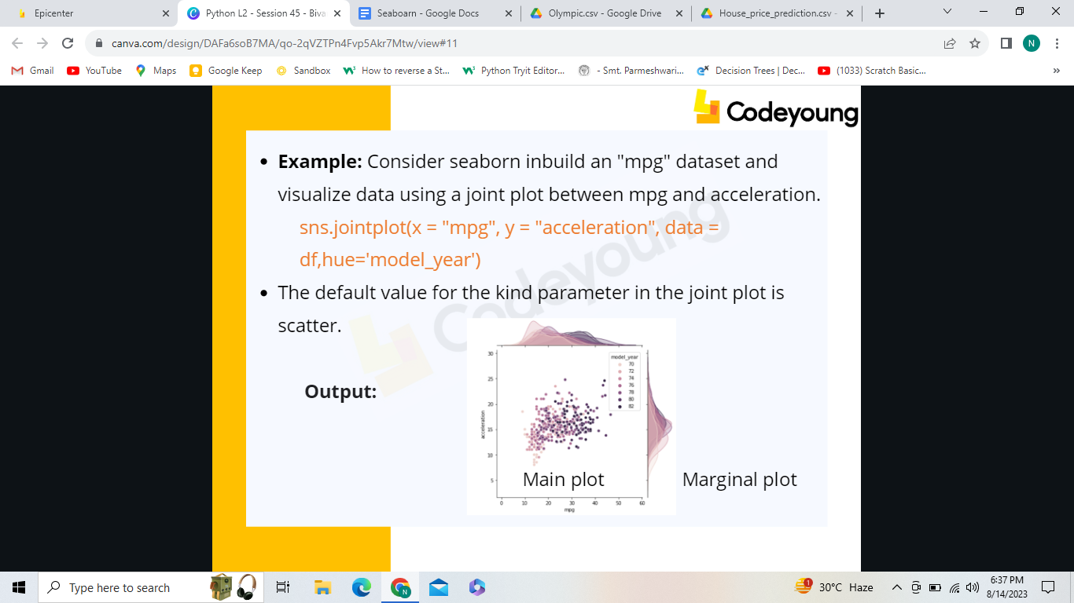

sns.jointplot(data=df, x="bill_length_mm",

y="bill_depth_mm",kind="hex")

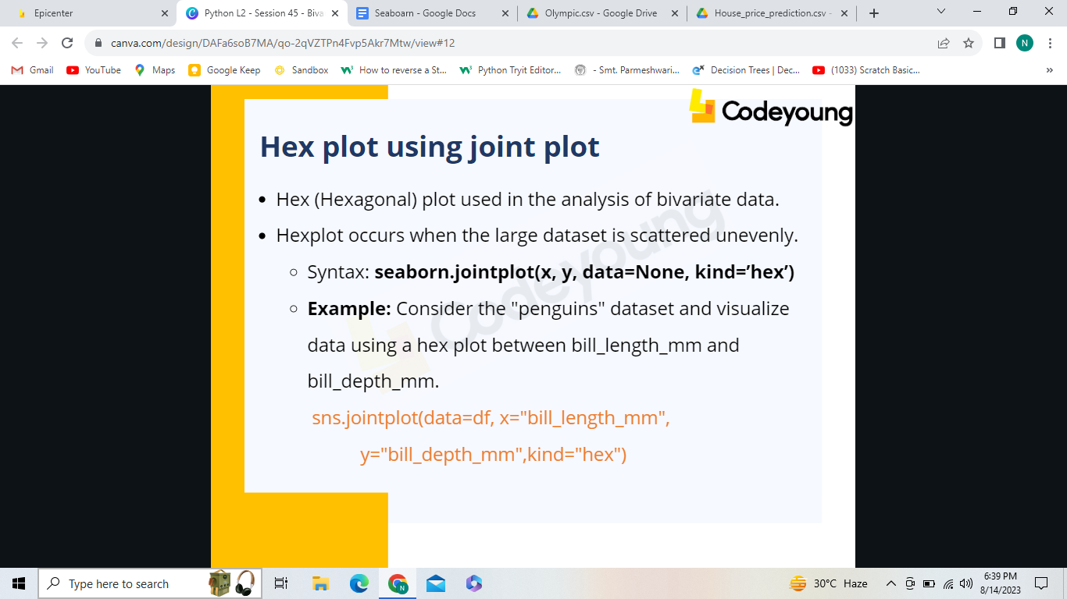

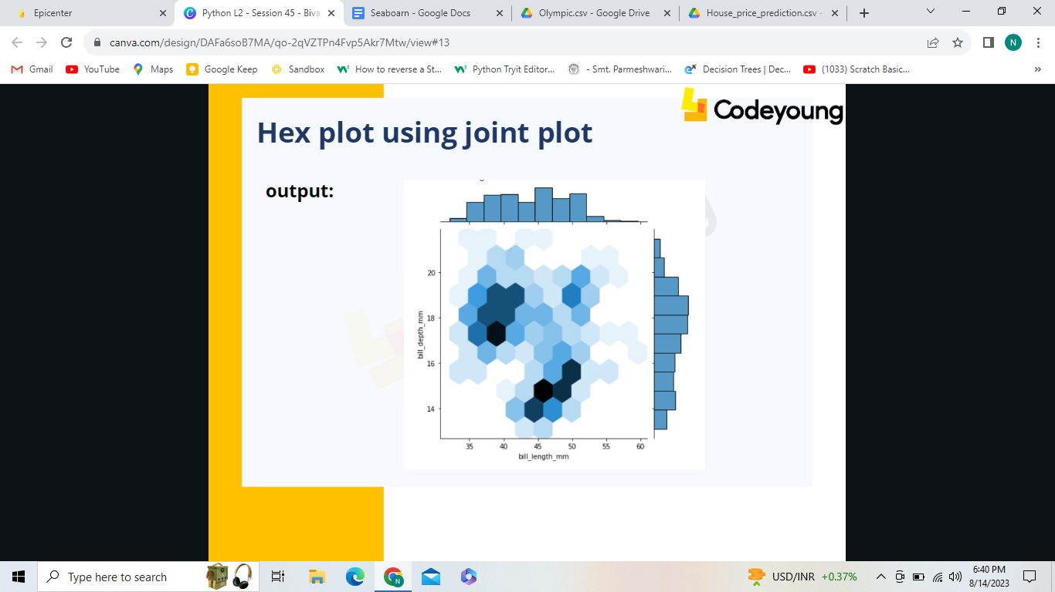

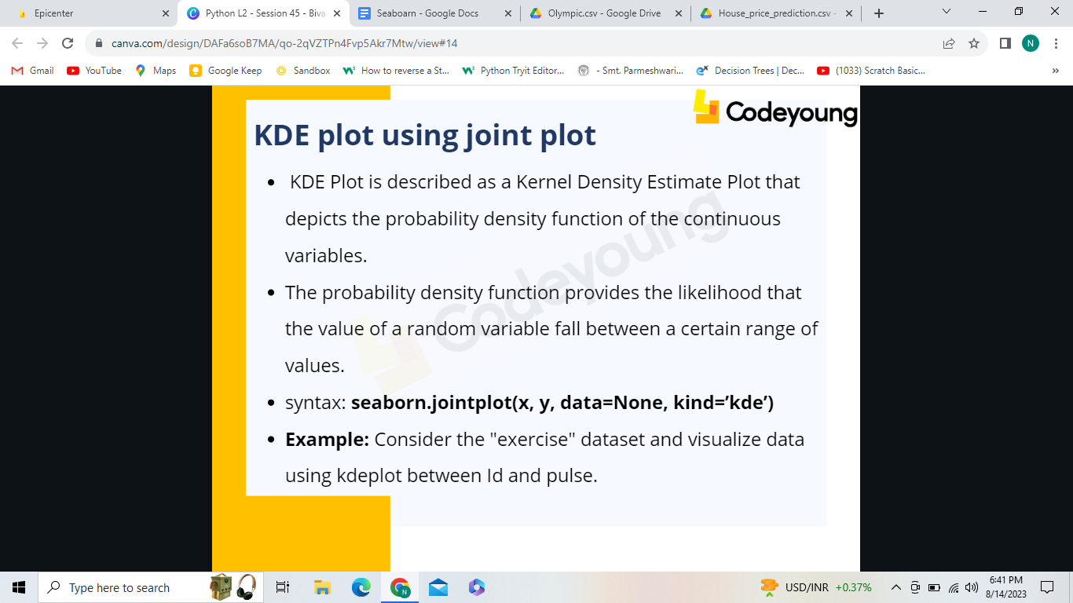

sns.jointplot(x = "id", y = "pulse",kind = "kde", data = df)

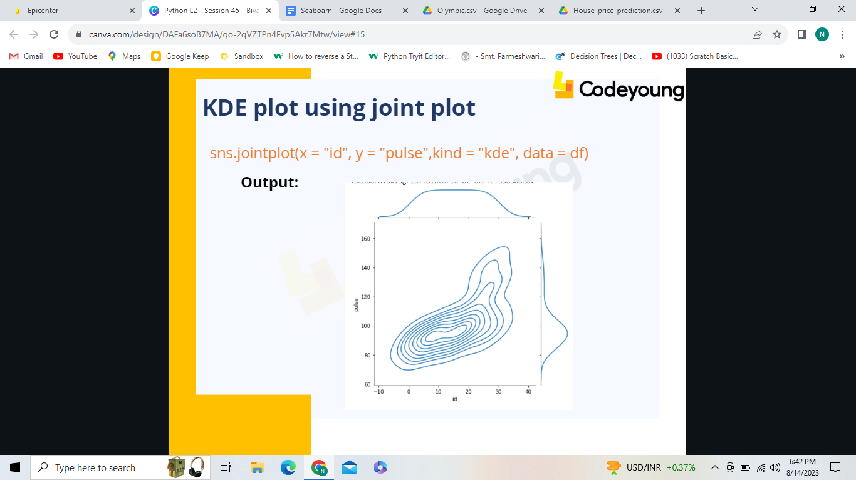

**IN CLASS ASSIGNMENT**

1. Consider "attention" inbuild seaborn dataset and visualize the data using a KDE plot between the subject and score.

2. ZSI (Zoological Survey of India) had done the survey on animals in zoo and wanted to visualize the data using hexplot.

[Dataset link: https://drive.google.com/file/d/1btJAHicloSeLZr-uBW2uuSQS8IIDmQlV/view?usp=share_link ]